Join us for this Yoga Alliance certified course:
- Yoga philosophy, history and evolution
- Yoga anatomy and asana methodology
- Meditation and pranayama techniques
- Proper sequencing and ethics of a teacher

For more information contact
Johanna at 815-501-5070 or
Johanna.godinez@hotmail.com

  - Beyond Asana Yoga Lifestyle
  - 200-hr Online Teacher Training
  - Online course begins August 15th

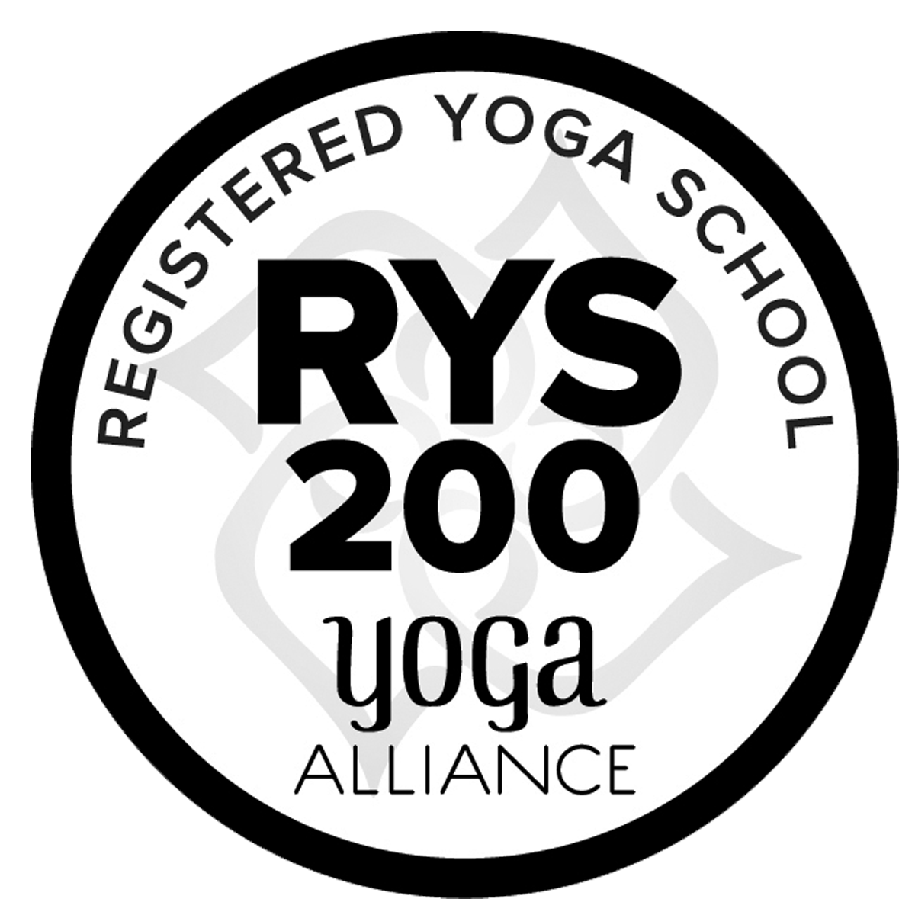
Only One Course Available as this will only be available Until September 30TH

B.A.Y. Lifestyle is a 200-hour Yoga Alliance registered school. Upon successful completion of this course you will receive a certificate that will qualify you to become a Registered Yoga Teacher when you join Yoga Alliance as a member

B.A.Y. Lifestyle Yoga Teacher Training

Dates
The course will last from August 15th until September 27th and will meet 6 days a week with the last week for final before September 26th with graduation on September 27th. With five days of exam and practice hours. The schedule is from 5-10am PST M-F. There are various practice times to choose from and flexibility with your practice hours.

Cost
The cost of the course is $699 and that includes ALL materials and PDF’s needed for successful completion

200hr YTT Course Content
Techniques, Training, Practice: Daily practice, analytics of yoga poses, correct position and alignment breakdown of poses, meditation and pranayama techniques
Anatomy & Physiology: Biomechanics, anatomy of poses and the subtle energetic body
Yoga Humanities: History, philosophy, ethics and texts including the 8 limbs, chakras and more
Professional Essentials: Teaching methodology, class design, voice development and teaching practice
Teaching Materials: Light on Yoga by B.K.S., Yoga Anatomy, Patanjali's Yoga Sutras, articles and videos
Bonus Classes: 30-day detox and cleanse and 21-day meditation challenge

Studies
Offline: You will be required to complete reading and writing assignments and submit teaching practice recordings. A summary review of all assignments will take place during live classes where you can ask questions to understand the topics in greater detail.
Online: B.A.Y. Lifestyle gives you the option to join 140+ hours of live classes until you complete the course. The options for classes are: Mon-Fri 5-10am PST, with ability to make up hours in the evening, and Saturday morning at 6:00-9:00am PST to attend review and discuss for you to choose from and Sunday will include an optional Q&A where we can review, discuss and clarify.

Instructors

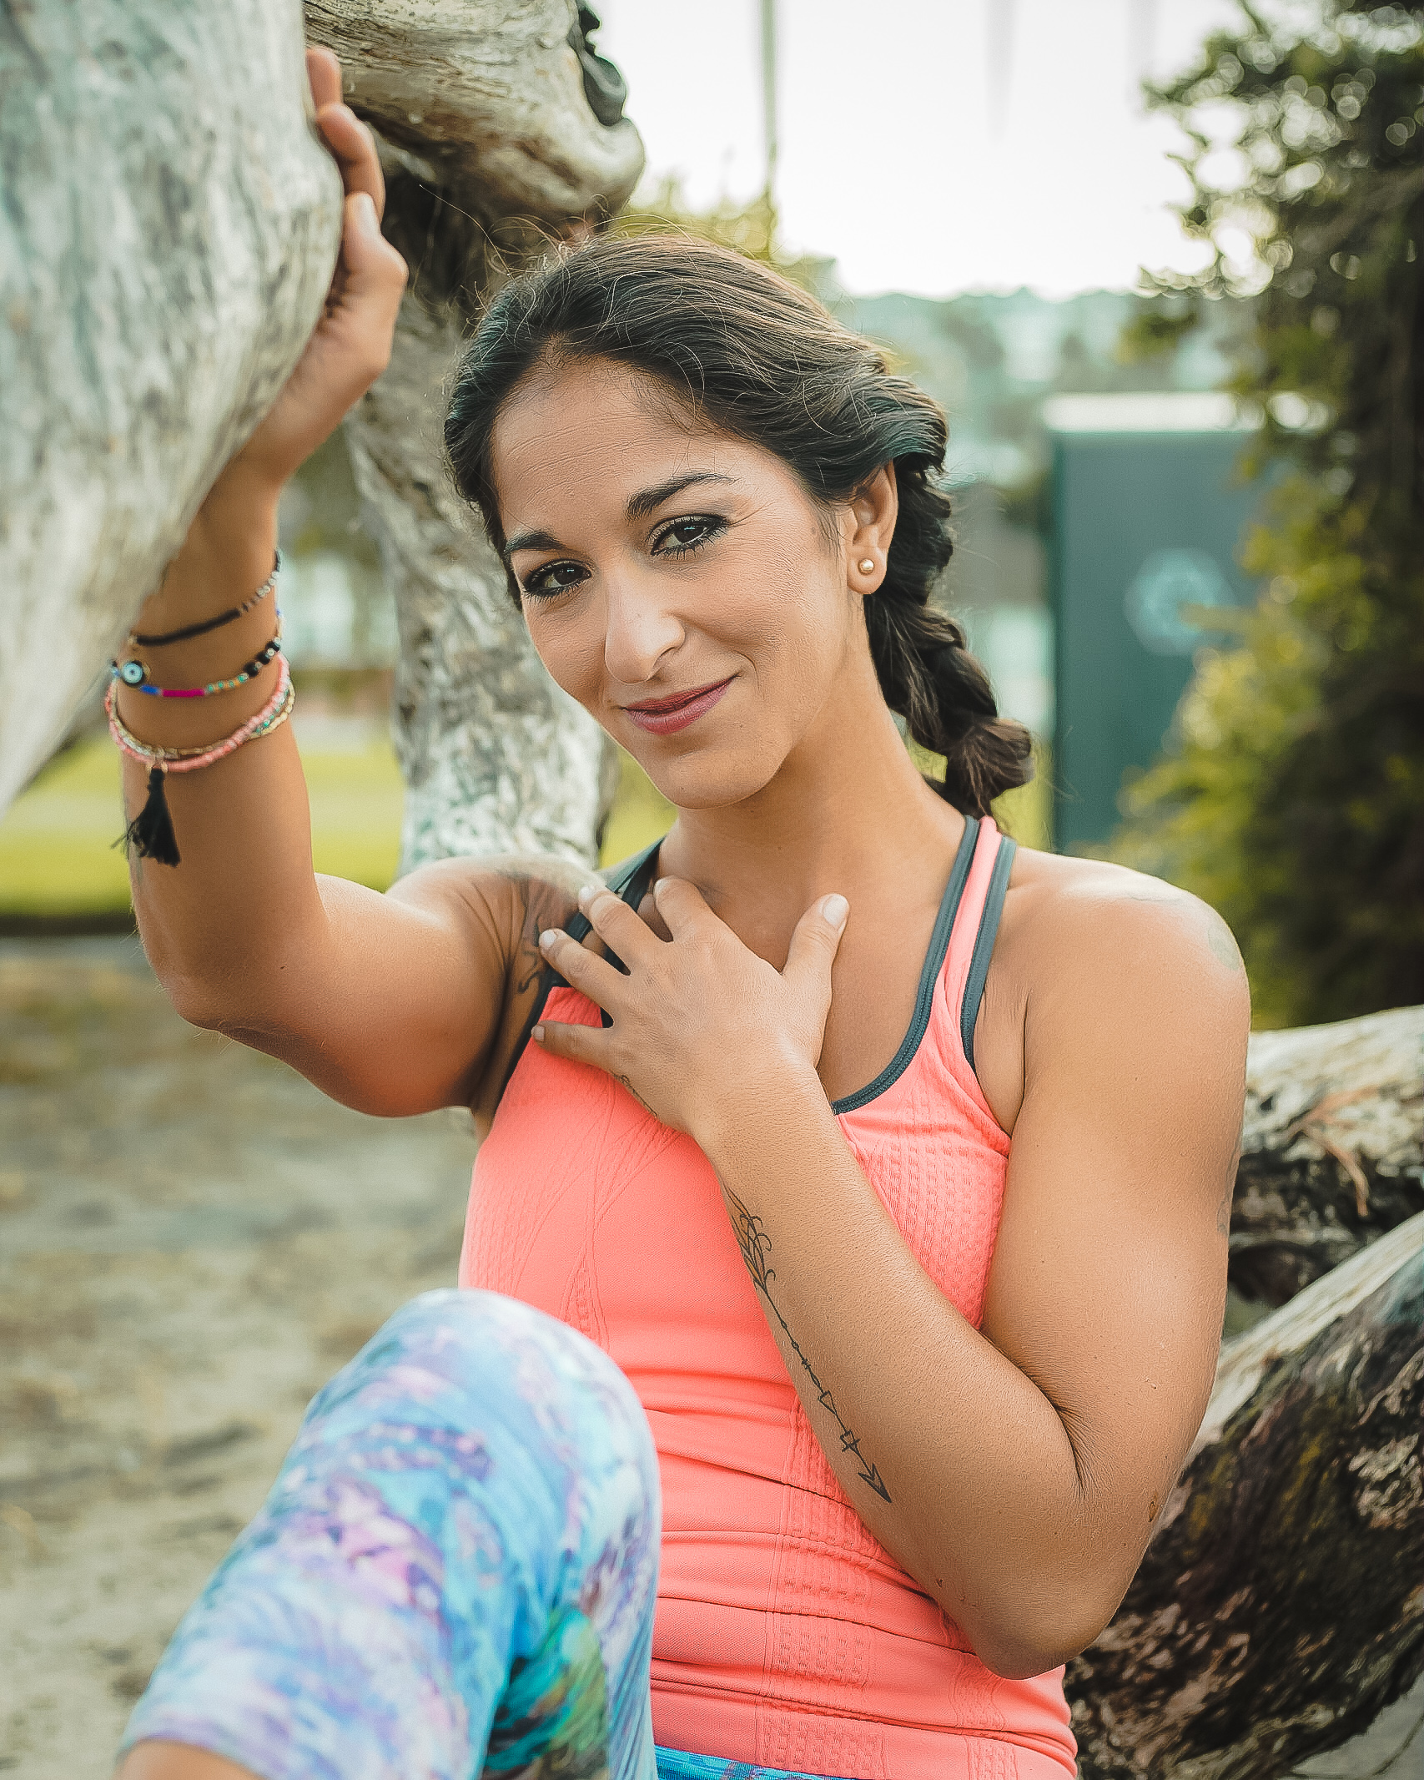
Johanna Godinez
Johanna Godinez is the founder of Beyond Asana Yoga Lifestyle. She stepped on the mat for the first time more than 15 years ago when she found herself at a crossroad in which Yoga illuminated the path. Her purpose now is to share the ancient knowledge and philosophy that has been around for thousands of years as a way to ignite in others self-exploration and enlightenment in this beautiful experience of life. As an E-RYT500 YACEP her passion is sharing not only the knowledge of Yoga, but the path to living Yoga beyond the mat.
Credentials:
- AYPR 200hr YTT
- Life Power Yoga 200hr YTT
- ULU Yoga 300hrYTT
- 4,500+ teaching hours in various Yoga modalities
- Leading 200hour YTT since 2017
- BS, MBA & Human Success Development Coach

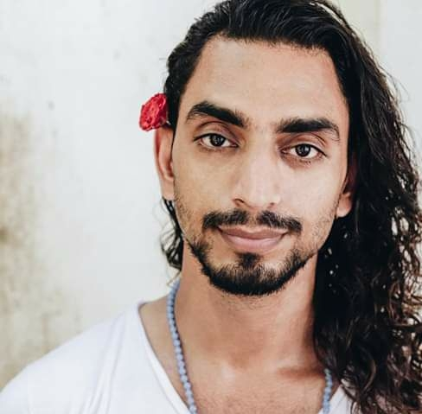
Manjeet Mathur
Manjeet Mathur began his self-awareness path in 2009. His approach to Yoga believes that the practice can be personalized for everyone. His highest purpose is to create Space and Peace in his daily life and invite others to also keep choosing their Higher Self, Intuition and Connectedness with all that exists. Manjeet’s passion for Yoga has led him to becoming the face of a Modern Mystic Yogi - grounded in self practice and also embracing life and the joys it offers.
Credentials:
- Parimukti 200-Hr YTT
- Parimukti 300-Hr YTT
- Yoga Therapy Modules 1 & 2 MultiStyle Yoga TT with Parimukti
- Certifications in Meditation and Iyengar yoga
- Has led over 50 yoga and meditation teacher trainings
- Specializing in Hatha yoga, Meditations, Practical Yoga Philosophy, Chakras, Pranayama and more!

